I would like to see the logo on the main page a little larger. Make the whole light blue area wider.

On The Master picture the works in the background “I’ve already handled it” make readable.

On the shared mission area do you think we should add the pics of the AI Team that I gave you?

In the area with the story behind the name. “Banana” did not begin as a family nickname.
It’s my grandma name what my grandbabies call me. You can say something like some grandma’s are called Granny, Glamma or Nana; this Grandma is Banana “Bad Nana”. I mean you can get creative with the wording. I just want it to be know Banana is my grandmommy name.

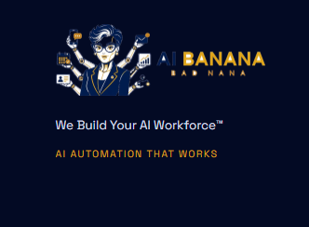
Bottom of Page I don’t like the darkness of this and be sure the logo doesn’t show a dark forehead like this one. I thought I had changed them all but it’s showing here.

Phone number is 855-970-NANA
Email: connect@get-aibanana.com
Location: is Charlotte, NC but since it’s an online business I can service any area. So IDK if we should pin it down to a location. Thoughts?

FB: https://www.facebook.com/profile.php?id=61588448423750
IG: https://www.instagram.com/get_aibanana/
LI: https://www.instagram.com/get_aibanana/
TikTok: AIBananabiz

The master render should not have a complexion she is a robot. I see the master I gave you she has a complexion let me fix that.

LIVE AI RECEPTIONIST CHALLENGE – MAKE THESE WORDS LARGER.

The darker blue to me is too dark. Meet Your AI Employees. Make the letters more white maybe. I don’t know exactly how to make it look better to me.

Book a strategy call I going to add a wix to this but I also want them to be able to book using an AI Receptionist

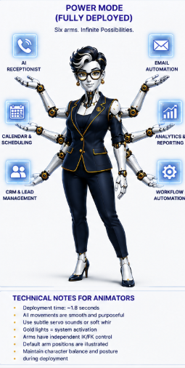
IDK if this is a tall ask. Can you do any automation? With this on the main page are you able to show like a task happens and then an arm comes out and another task and another arm, so on and so on. Like after two or three slow arms then all them can come out quicker. If possible.

Industries we serve Built for Business that Never stop. (This dark blue) The white here is better brighter.

